Assignment - RDD Commands

Creating new list with a value
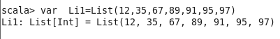
Creating a new rdd for the list
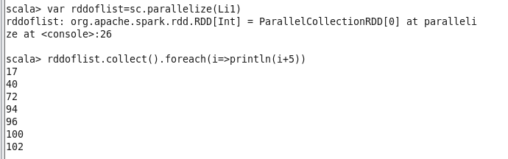

Count operation:
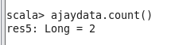

Read file from source
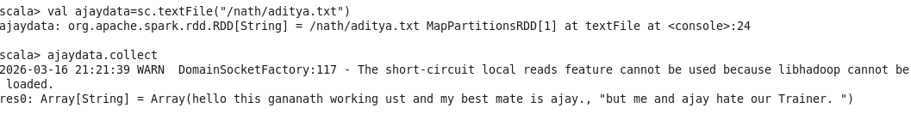

Using a keyword to separate data

To find length of array (RDD collected result)
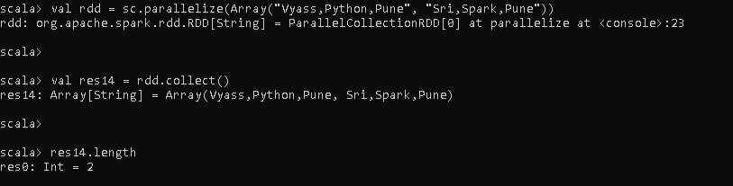
To check value using index
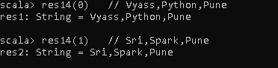
Starting keyword
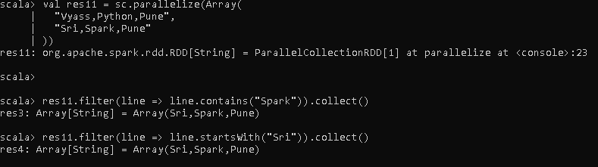
Line Operations:
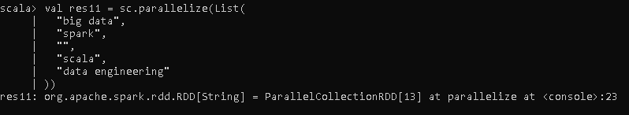

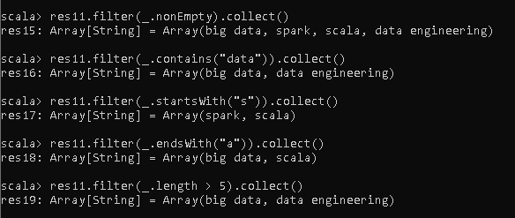
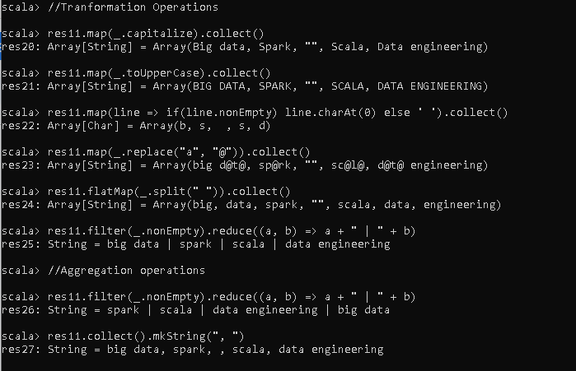

Creating two arrays for UNION
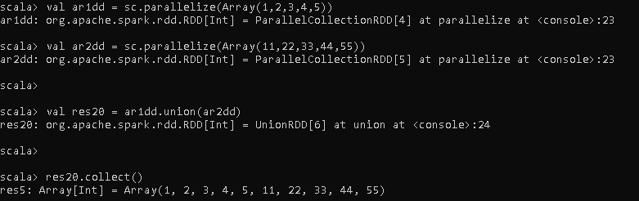

Intersection
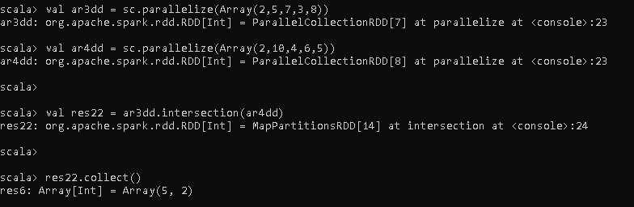

Join function
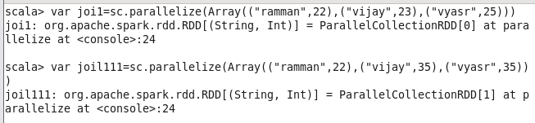
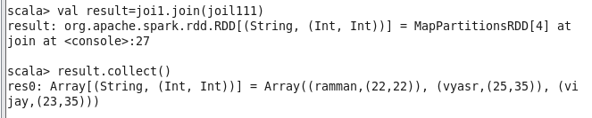

Using index to get value
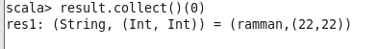
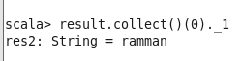
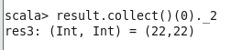
Using values to print in a proper format
Print multiple values using for loop
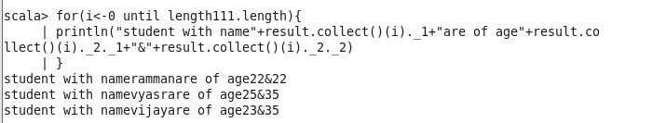

Using mapreduce in RDD:(word count)
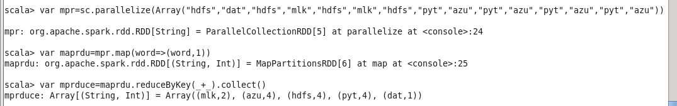
Group by key
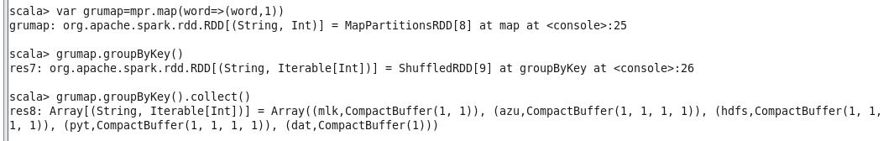
Map value

Aggregation of integer values
Add:
Subtract:
Changing the parallelism:
Take order;does the order selection on the basis of the given array value

Save File

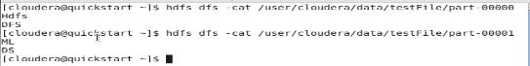

Saving the file in map format
